 | Grand River Mustangs  Remembrance Day Classic  November 8 - November 10, 2024  Tournament Rules  OWHA Sanction #2425069
- All Teams are required to in person Register at Headquarters CENTRE WELLINGTON Arena inside the tournament office either before or immediately after your first game in the event. Hockey Canada and OWHA SUSPENSION rules shall apply where required. Any team using an OWHA Pickup Players must follow these rules of face Forfeiture and or Suspensions and fines. Teams may use the MAX 3 of 3 Players to Replace Existing players on their Official Roster. You can NOT Replace Suspended players. Rep teams may only use Players from below levels of play – No Lateral Callups even if playing up in a combined division. Please note at no time can you exceed the total # of players on your official Roster. The use of an official OWHA Pickup can only be accessed inside your teams RAMP acct, we are no longer are allowed to accept paper versions.
- All games will consist of 3 periods (11 minute -11minute-11 minute), stop time with the exception of the U9 division that will play 2 x 23 min periods run time using a 90 Second buzzer shifts. U9 Visitors will change ends at the half.
- There will be a 3 min warm-up prior to each game. All games begin immediately upon completion of the 3 min warm up. The clock will NOT stop at the 11 min mark but will continue until the first stoppage of the game.
- All teams Must be available to play up to 20 min prior to the scheduled start time where required at the discretion of the arena convenor.
- The OWHA minimum suspension guidelines will be strictly enforced. All suspensions will be enforced according to the OWHA ANNUAL Constitution, By-laws, and Regulations & Rules.
- Girls will tap gloves after each game.
- If the goal spread at any time of the third period reaches 5 goals, the clock will run until the spread is reduced to 3 goals, then stop time will resume.
- One - 30 second timeout will be allowed for each team ONLY during Elimination - Quarter - Semifinal & Championship games only. Overtime is not a new game. There is NO TIMEOUT in Round Robin or Consolation Games.
- A maximum 17 skaters and 2 goaltenders may be registered with each team.
- A player may only participate with one designated team in a tournament and may only participate in one tournament on any date.
- To be eligible to participate in the tournament, the participant’s name must appear on the team roster form submitted with the entry form. Changes to the roster must be made in writing and will not be permitted after registration prior to the first game. Players on Ontario teams must be registered with the OWHA. The OWHA “Pickup Consent” forms will be honored and must be included where necessary based on OWHA Rules.
- Teams will be awarded 2 points for a win, 1 point for a tie and zero (0) points for a loss.
- Standings after the round robin will be calculated on the basis of the points awarded as per rule # 12. In the event of a tie, the following criteria will be used to break the tie:
- Winner between the tied teams when they played head to head. (Applies to 2way ties only, 3 or more teams tied start with tied breaker 13b.)
- Percentage as calculated by dividing team’s total “Goals For” by the SUM of the team’s “Goals for and Goals Against”. TG ÷ (GF+GA) = % (See Tie Breaker Ratio Chart)
- Fewest Goals Against.
- Most Goals For.
- Fewest Penalty Minutes.
- Coin Toss.
- Follow Tie breaking rules in Order. Once a Tie Breaking Rule has been used or is not applicable it cannot be used again.

- IF a team(s) remove prior to the event (up to 72 hrs. before) every opportunity will be made to find a replacement team. If, however a team cannot be found where One or BOTH teams are unable to ice a team, or facilities breakdown / malfunction or game cancellation due to inclement weather, COVID and PHU or Provincials orders prevent teams from attending we will unfortunately NOT be able to reschedule the game. If unable to reschedule the game(s) will be considered as an Official OWHA Forfeiture score. It will be recorded as either 5-0 for a “single team no show” or if both teams are unable the score will be recorded as a Hockey Canada Forfeiture of a 0-0 tie for both teams to assist in determining rankings to find a divisional winner as required in conjunction with tie breaking rules. Tournament organizers and committees are not liable or responsible for acts of God and unforeseen events mechanical breakdowns, causing the cancellation of any part of whole if this event. ONLY 1 team official will sign the game sheet prior to each game
- In 4 Team Divisions: After Round Robin play 1st and 2nd place overall will advance to the Championship finals with the 3rd and 4th place teams playing a Consolation game.
- In 6 Team Divisions: After Round Robin play the teams will be ranked 1st through 6th overall. 1st and 2nd place teams advance to Semi-Finals while teams ranked 3rd through 6th will play elimination games with the winners advancing to the Semi-Finals.
- In 8 Team Divisions: There will be two pools of 4 teams. After round robin play teams will be ranked 1st through 4th in each pool. 1st and 2nd place teams in each pool will advance to the semi finals while 3rd and 4th place teams in each pool will play a consolation game. The winner of each semifinal will advance to the Championship game.
- In 12 Team Divisions: There will be two pools of 6 teams. After round robin play teams will be ranked 1st through 6th in each pool. 1st through 4th place teams in each pool will advance to the quarter finals while 5th and 6th place teams in each pool will play a consolation game. The winner of each quarter final will advance to the semifinals with the winners advancing to a Championship game.
- Elimination, Quarter Finals, Semi-Finals & Championship games are played to a winner. In the event of a tie at the end of regulation time a Sudden Victory 5 min overtime will commence. Teams will play 4 on 4 PLUS Goalies. (See format for rules) Players may be changed at any time. Goalies may be “pulled” at any time and a substitute player from the bench may be used. If still tied, a shootout will occur.
- Shoot Outs: Teams do not change ends for Overtime or Shoot Outs.
Each team must designate 3 shooters (S1, S2, S3) directly onto the game sheet prior to the start of the game.
Any player serving a penalty at the end of overtime will not be eligible to participate in the shootout and MUST remain in the penalty box. All players except shooter and goalies will be on the bench. Once a player has shot, they will go to the penalty box. Shooters from both teams will shoot simultaneously, starting at centre ice.
This is a BEST OF 3 Shootout. If still tied, each team will designate one shooter at a time until there is a winner.
A player may not shoot for a second time until all players on the game sheet (except goalies) have shot.
- Home teams must wear light colored jerseys where possible. In the event of a conflict, the home team must change their jerseys. Visiting teams will advise opposing team of any conflict 30 minutes prior to game time. Pinnies may be used as required. House teams are requested to bring 2nd set of jerseys or Pinnies to avoid conflict.
- Flooding of the ice will occur at the end of each game or as required and may be deferred at the Tournament Committee’s discretion.
- It is the team’s responsibility to ensure a clean dressing room is left upon completion of their game. All teams are requested to vacate the dressing room 30 minutes or less after their game is completed
- The decisions of the Tournament Officials are final with no appeals!!

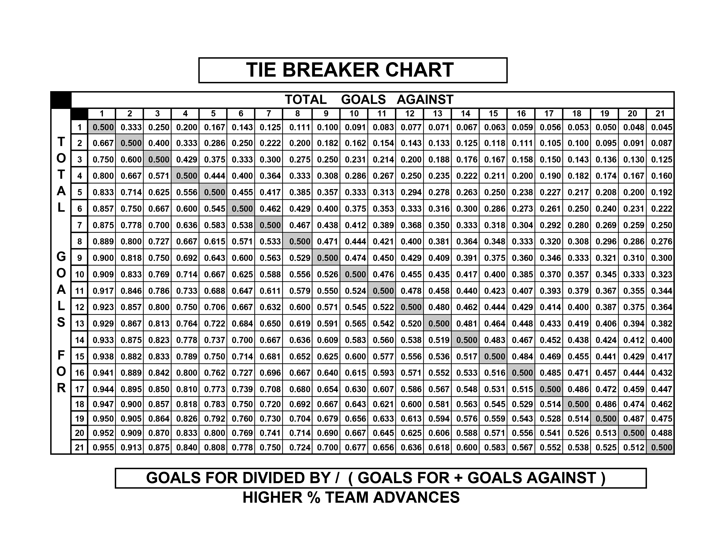
GOOD LUCK TO ALL TEAMS PARTICIPATING IN THIS HISTORIC EVENT!!
**WE RESPECTFULLY ASK FOR YOUR ASSISTANCE IN THAT NO TEAM PHOTOS
BE TAKEN ON ICE DUE TO Municipality & City Insurance Regulations.
*Championship Awards and Medals / Banners
WILL be Presented Off- Ice and will be distributed by coaching as required.
Reminder ALL Suspended Athletes and Bench Staff may not participate in medal presentation ceremonies as per OWHA Rules. We thank you for your anticipated support in this matter.

Grand River Mustangs

Remembrance Day Classic

November 8 - November 10, 2024
Elimination, Semi-final, Quarter Finals and Championship games Tournament Rules

OWHA Sanction #2425069
- Elimination, Semi-final, Quarter Finals and Championship games are played to a winner.
- In the event of a tie at the end of regulation time a SUDDEN VICTORY FIVE (5) MINUTE OVERTIME will commence.
- Overtime will be played 4-on-4, plus goalies
  - Any penalties being served at the end of regulation time will carry over to the overtime period.
  - Example 1: If a team is one player short, then overtime will start 4-on-3.
  - Example 2: If a team is 2 players short, they OT will start 5-on-3. On ice strength will be adjusted back to 4-on-4, as per OT rules, at stoppages of play after the penalties expire.
- Clarifications:
  - If a penalty is assessed to one team during the overtime period, play shall resume 4-on-3
  - Should a second penalty be assessed to the same team, play will resume 5-on-3 until the expiry of the first penalty.
  - If the penalty expires during play, the player shall return to the ice and teams will play 5-on-4 until the next stoppage of play, at which point the on-ice strength will be adjusted to 4-on-3, etc.
  - At no time will a team have fewer than 3 skaters (plus goalie) on the ice
- Teams will play 4 on 4 plus goalies. Players may be changed at any time. Goalies may be “pulled” at any time and a substitute player from the bench may be used.
- Penalties do NOT expire at the end of regulation time.
- If still tied, a shoot out will occur.
- Each team MUST designate 3 shooters (S1, S2, S3) on the game sheet BEFORE the start of the game.
- Any player(s) serving a penalty at the end of overtime will not be eligible to participate in the shoot out and MUST remain in the penalty box. The coach must designate a shooter(s) to take her place(s) immediately at the end of regulation time.
- All players except shooter and goalies will be on the bench TO START.
- Shooters from both teams will shoot at the same time starting at the centre ice red line.
- Once a player has shot, they will go directly to the penalty box.
- This is a BEST OF 3 Shootout.
- If still tied, each team will designate one shooter at a time until there is a winner.
- A player may not shoot for a second time until all players on the game sheet signed (except goalies) have shot.
- A penalty assessed in regular time will carry forward to the overtime period. Therefore, the player will not come out of the box.
**WE RESPECTFULLY ASK FOR YOUR ASSISTANCE IN THAT NO TEAM PHOTOS
BE TAKEN ON ICE DUE TO Municipality & City Insurance Regulations.
*Championship Awards and Medals / Banners
WILL be Presented Off- Ice and will be distributed by coaching as required.
Reminder ALL Suspended Athletes and Bench Staff may not participate in medal presentation ceremonies as per OWHA Rules. We thank you for your anticipated support in this matter.

